Tutorial 5

Chapter 5

- Natural language is one of the commonly used techniques for requirement documentation (RD). Discuss 2 advantages and 2 disadvantages of natural language.

Advantages | Disadvantages
- Unlimited expressiveness  - Communicability | - Lack of clarity
- No training needed | - Requirement amalgamation

- Recently you have been assigned to work on a project to implement an online airline ticketing system. Assume that your team has reached Requirements Specification phase, prepare a requirements document template that you would use for preparing the requirements document for the project.
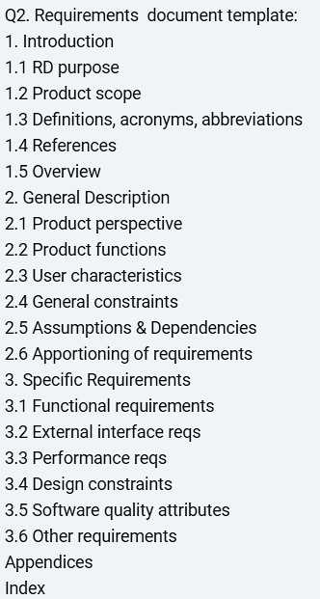

- Diagrammatic technique is another commonly used technique for producing RD.
- Discuss why software engineers would usually use more than one diagrams in preparing RD?
Diagram for different type cover different complimentary view of a system. For example, software engineer will use usecase diagram to capture operation to be performed by a system component and interaction with other component, R net diagram captures all the required responses to single stimulus and state diagram capture the admissible behaviors of system’s component

Can software engineer use different diagram to show component and interfaces, conceptual structure, operations, flows, interaction scenarios and system behaviors.

- Assume that your team has decided to adopt diagrammatic approach on requirements documentation, recommend FOUR (4) diagrams that you would include in the requirements documentation for a project. Explain each of the recommended diagrams by specifying its usages and the information presented in the diagram.
Context diagram
ERD
Data flow diagram
Use case diagram
Event trace diagram
State machine diagram

- Evaluate the use of diagrammatic approach on requirements documentation.
As a system’s diagrammatic approach on requirements documentation:
- Overview structuring as important aspect
- Easy to understand, communicate
- Surface level analysis, supported by twos
Disadvantage of diagrammatic approach:
- Lack of two support
- Costly on diagrammatic tools

- Give and explain ONE (1) example of inter-view diagrams consistency rule between Context Diagram and DFD.
Any data flow in context diagram must appear in corresponding DFD
(Chapter 5 slide 24 & 29)
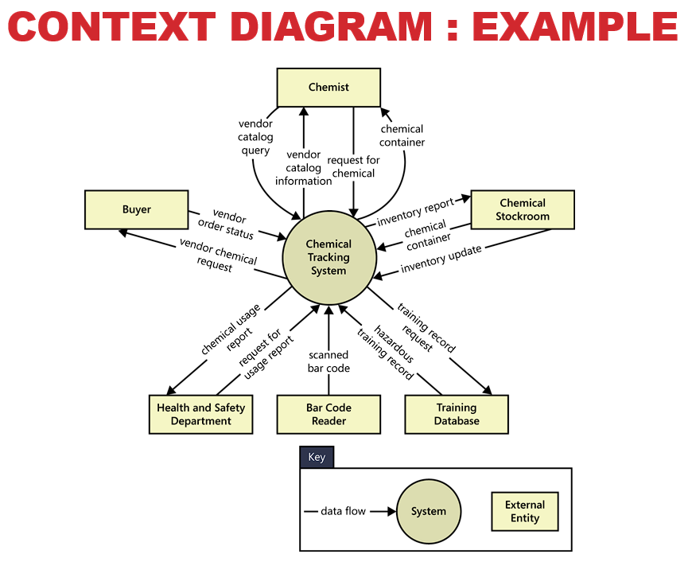
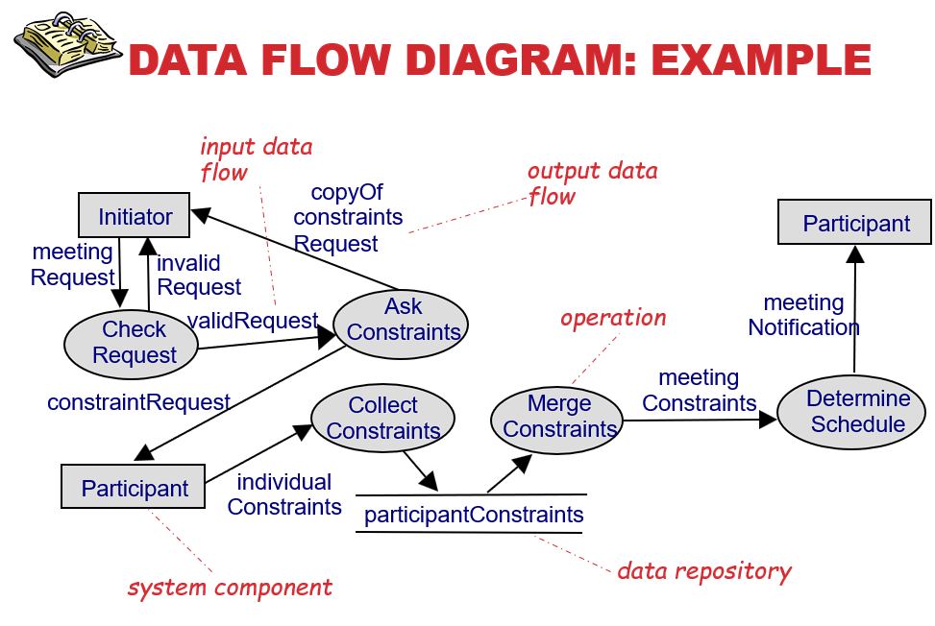

- Formal Specification on Requirements Documentation:
- Differentiate between Algebraic approach and Model-based approach in formal specification.

Algebraic Approach Model-based Approach

Algebraic Approach | Model-based Approach
Algebraic approach – system is described in term of operations and their relationship. Last system are normally comprised of subsystem with well defined interfaces. Specification of these interfaces allows of their independent development. The algebraic approach is particularly well suited to the specification of such interfaces | System is specified in term of state model that is constructed using mathematical construct such as sets and sequences. Operations are defined by modifications to the system state. Z is a mature notation for model-based specification. The basic will involved of Z based specification as schema. Schema identify state variable sand define constraint and defined in term of variable

Tutorial 5 (Cont’)

- Suggest a project scenario where formal specification is applicable. Justify your answers.
Mission critical / Life critical system where the failure of the system might cause loss of life and also might bring harm and to the environment. Formal specification will be recommended here to be reduce the system flow as common specification as express as a mathematical operation with precisely vocabulary, syntax, and semantics.
Furthermore, specification is most likely to be cause effective where high system failure cost can be avoided as well as high testing time/ effort/cost can also be avoided where the requirement inspection exercise can be performed with help of tools

- Discuss the TWO(2) reasons why formal specification approach is not commonly used for requirements documentation.
- Other software engineering have been successful as increasing system quality
- Include market changes have make time to market rather than software with a low error count the key factor
- The scope of formal method is limited. They are not well suited to handle user interfaces and user interaction
- Formal method are hard to scale up to large system

- Explain any 2 advantages of formal specification.
- The principal benefit of formal method are introducing the number of force system
- Formal methods are most likely to be cost effective where high system failure cost must be avoided

- Comment on the two quality requirements from the RD (as below) that prepared by your project team. Suggest how would you improve the following quality requirements:

- Performance
The system shall have fast respond time to any authorization request.

- Reliability
The system shall have low system down time.

- What is quality trade-off? Use example to explain your answer.
Refer lecture slide

- Discuss any THREE (3) guidelines for writing excellent requirements that covered in lecture.
Refer lecture slide

- XYZ College organizes a free seminar entitled “Programming is Fun” to the public. Given the use case diagram as shown in Figure 1, construct an analysis sequence diagram that shows the normal flow of events for the use case “Register a seminar”.

Figure 1

